# Task 1: - New Milestone

First Create New Custom Object Name “New Milestone”

And Fields Name: -

1. [Milestone Name](https://kailashlalwani-dev-ed.lightning.force.com/lightning/setup/ObjectManager/01I5g000002i2VO/FieldsAndRelationships/00N5g00000Q5Hzd/view)

2. [Notified to When Complete](https://kailashlalwani-dev-ed.lightning.force.com/lightning/setup/ObjectManager/01I5g000002i2VO/FieldsAndRelationships/00N5g00000Q5HjE/view)

3. [Description](https://kailashlalwani-dev-ed.lightning.force.com/lightning/setup/ObjectManager/01I5g000002i2VO/FieldsAndRelationships/00N5g00000Q5Hil/view)

Create an application is Salesforce Name

“**Assignment2**”

Search in App Navigation bar: -

“**Assignment2**” then Click

This Page is open: -

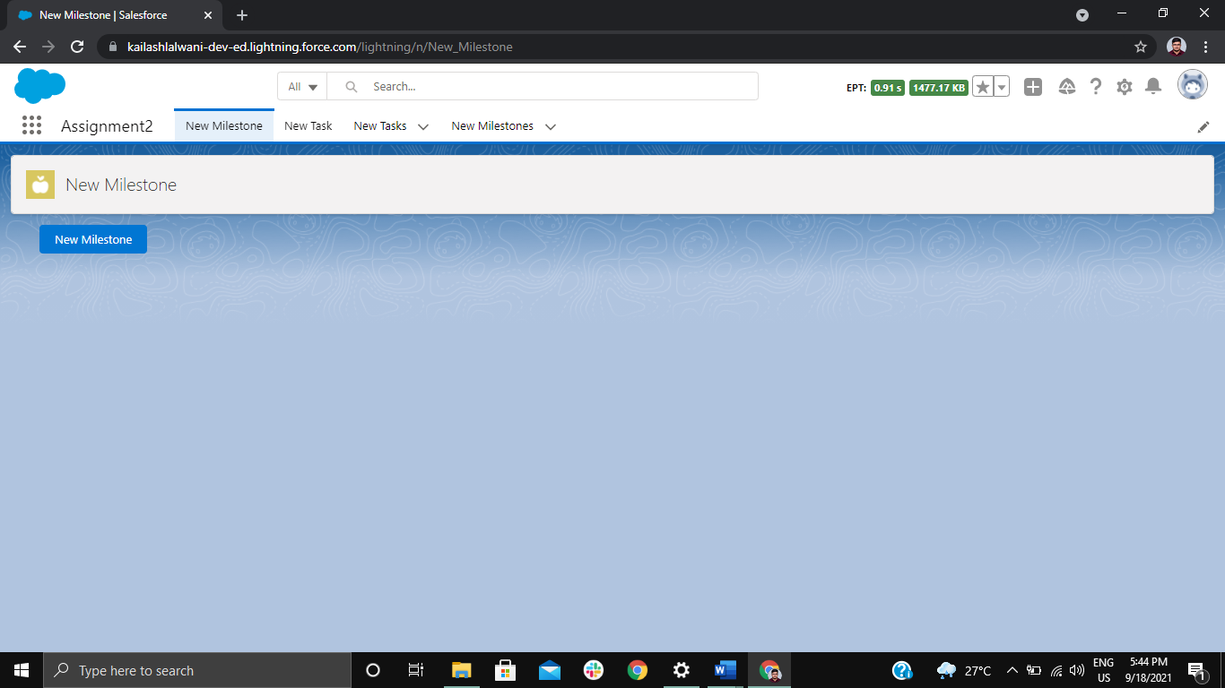

When We Click on **New Milestone** Button: -

This Popup Will Open: -

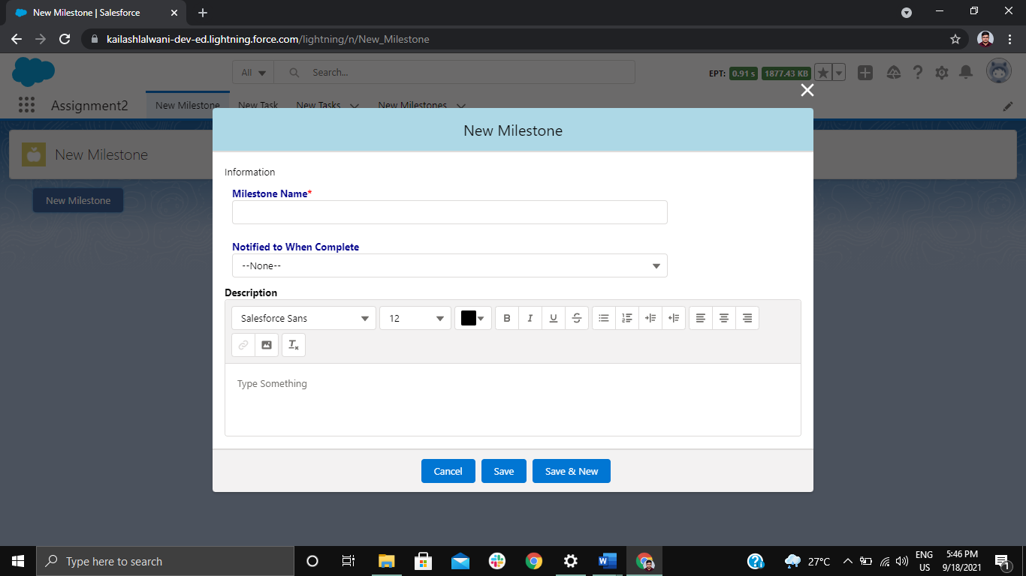

**Enter the Values and Stored in: -**

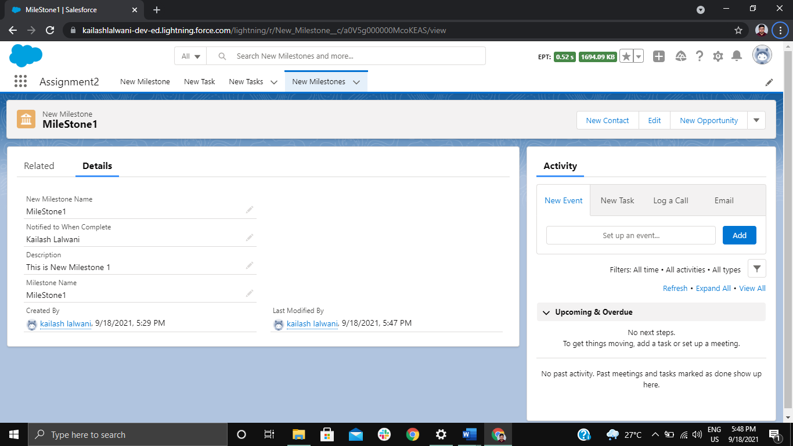

# Task 2: - New Task

First Create New Custom Object Name “New Task”

And Fields Name: -

1. [Task Name](https://kailashlalwani-dev-ed.lightning.force.com/lightning/setup/ObjectManager/01I5g000002i4AH/FieldsAndRelationships/00N5g00000Q5RZh/view)
2. [Notified to When Complete](https://kailashlalwani-dev-ed.lightning.force.com/lightning/setup/ObjectManager/01I5g000002i4AH/FieldsAndRelationships/00N5g00000Q5SmM/view)
3. [End Date](https://kailashlalwani-dev-ed.lightning.force.com/lightning/setup/ObjectManager/01I5g000002i4AH/FieldsAndRelationships/00N5g00000Q5Ra1/view)
4. [Predessor Task](https://kailashlalwani-dev-ed.lightning.force.com/lightning/setup/ObjectManager/01I5g000002i4AH/FieldsAndRelationships/00N5g00000Q5RbE/view)
5. [Milestone](https://kailashlalwani-dev-ed.lightning.force.com/lightning/setup/ObjectManager/01I5g000002i4AH/FieldsAndRelationships/00N5g00000Q5RbY/view)
6. [Priority](https://kailashlalwani-dev-ed.lightning.force.com/lightning/setup/ObjectManager/01I5g000002i4AH/FieldsAndRelationships/00N5g00000Q5Rbx/view)
7. [Assign to](https://kailashlalwani-dev-ed.lightning.force.com/lightning/setup/ObjectManager/01I5g000002i4AH/FieldsAndRelationships/00N5g00000Q5RcH/view)
8. [Description](https://kailashlalwani-dev-ed.lightning.force.com/lightning/setup/ObjectManager/01I5g000002i4AH/FieldsAndRelationships/00N5g00000Q5RcR/view)

Create an application is Salesforce Name

“**Assignment2**”

Search in App Navigation bar: -

“**Assignment2**” then Click

This Page is open: -

When We Click on **New Task** Button: -

This Popup Will Open: -

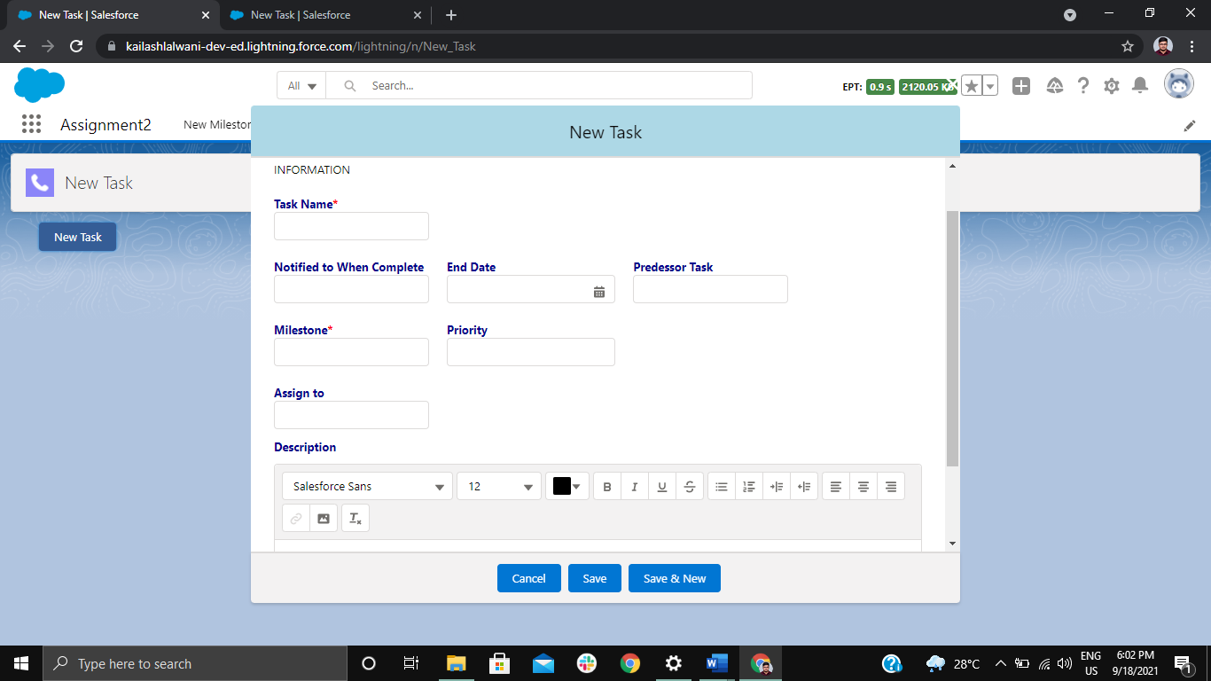

**Enter the Values and Stored in: -**

